Investigation of MnBi-based composite magnets

Parashu Kharel¹, Gavin Baker¹, Manish Neupane¹ and Tula R Paudel²
¹Department of Physics, South Dakota State University, Brookings, SD 57007, USA
² Department of Physics, South Dakota School of Mines and Technology, Rapid City, SD 57701, USA

Rare-earth-free permanent magnet materials have attracted much attention due to a limited supply and high price of the rare-earth metals used in current high performance magnets. MnBi and MnBi-based materials have been investigated as prospective rare-earth-free permanent magnets with moderate energy product. We have synthesized Mn₅₅Bi₄₅C_{x} magnet using arc melting and high-vacuum annealing. The composite magnets Mn₅₅Bi₄₅C_{x}-Fe and Mn₅₅Bi₄₅C_{x}-Co were prepared by grinding Mn₅₅Bi₄₅C_{x} with commercially available Fe and Co nanoparticles using mortar and pestle. The room temperature x-ray diffraction patterns indicate that Mn₅₅Bi₄₅C_{x} crystallizes in the hexagonal NiAs-type structure. The high-field (3T) magnetization measured at room temperature for Mn₅₅Bi₄₅C_{x} is 60 emu/g and that for Mn₅₅Bi₄₅C_{x}:Fe (10:1) is 71 emu/g consistent with the theoretical prediction. The coercivity measured at 300 K for Mn₅₅Bi₄₅C_{x} and Mn₅₅Bi₄₅C_{x}:Fe are 17 kOe and 9.0 kOe, respectively. In this presentation I will also discuss the data collected on Mn₅₅Bi₄₅C_{x}-Co samples. (Copied from APS abstract, need modification)

- Introduction
Rare-earth-element-based permanent magnets namely Sm-Co and Nd-Fe-B developed respectively in 1960’s and 1980’s play a critical role in advancing modern technology including electrical vehicles, wind turbines, phones, refrigerators, missiles, jets etc. [1, 2]. A key characteristic that makes a permanent magnet useful is its energy product ${(BH)}_{max}$, which depends on coercivity $H_{c}$, remanence $M_{r }$and the squareness of the hysteresis loop. Magnetization is an intrinsic property of a magnet where the upper limit of $M_{r}$is its saturation magnetization $M_{s},$ but the coercivity can be improved by optimizing its microstructure through sample processing and also by increasing the value of magnetocrystalline anisotropy energy through elemental substitution [3]. The theoretical maximum of ${(BH)}_{max}$ for a magnet showing an ideal square hysteresis loop is ${J_{s}^{2}}/{4 , }$ where $J_{s}=4πM_{s}$. For most technological applications, a permanent magnet should retain a high value of ${(BH)}_{max}$ up to at least 200 ºC. At present, the dysprosium containing Nd₂Fe₁₄B magnets with ${(BH)}_{max}$ of about 40 MGOe and working temperature of about 230 ºC are the most promising commercial permanent magnets [4]. However, high price and issues with the supply of rare-earth elements make them less favorable for widespread future technological applications. This situation has prompted a search for rare-earth-free permanent magnets.
MnBi in the hexagonal NiAs-type crystal structure is one most promising candidates of low-cost, rare-earth-free permanent magnets among several other magnets including Mn2Ga, FeNi, Zr₂Co₁₁, YCo5, and HfCo7 [5-12]. The main advantage of MnBi is its large magnetocrystalline anisotropy, which increases with increasing temperature reaching a maximum value of 22 Mergcm⁻³ at 590 K. This feature is important for high temperature magnetic stability against thermal agitation [13]. However, a low saturation magnetization and high sensitivity to ambient oxygen limit its prospect for commercial application. Therefore, there have been extensive research efforts to improve its magnetic properties through suitable third element doping but the experiments have not led to expected outcomes [7, 14, 15]. Another approach to improve its magnetic properties is to develop a hard-soft exchange coupled nanocomposite magnet using MnBi as the hard component [16,17]. Exchange coupled magnets exhibit large ${(BH)}_{max}$ utilizing high coercivity from hard phase and high magnetization from soft phase of nanocomposite. Significant improvement in ${(BH)}_{max}$ due to exchange coupling has been demonstrated in MnBi:FeCo thin films but the thin film structures are not suitable for permanent magnet applications [18]. Our interest is to develop MnBi- based composite permanent magnet. Here, we have investigated the magnetic properties of MnBi:Fe composite magnets.
- Experimental Methods
Mn-Bi ingots having elemental composition Mn₅₅Bi₄₅Cx (x < 5) were prepared using arc-melting and high-vacuum annealing. Commercially available Bi pieces, previously melted Mn and carbon power in proper weight ratio were melted together on a water-cooled Cu hearth of an arc furnace in an argon environment. Although targeted composition was Mn₅₅Bi₄₅C₅ , the ingot may not have that composition since some unalloyed carbon was found in the crucible after melting. We have found that Mn-Bi prepared in the presence of carbon contains less residual Bi as compared to the sample prepared without carbon [19]. The arc melted ingot was annealed in a tubular vacuum furnace (∼10⁻⁷ torr) at 400°C for 8 hours. In order to make MnBi:Fe composite, the annealed ingot was crushed into a fine powder, mixed with commercially available Fe nanoparticles, and ground in acetone for 15 minutes using mortar and pastel. We also made similar composite samples using carbon coated Fe nanoparticles. We prepared three batches of composite samples with Mn₅₅Bi₄₅Cx to Fe ratio of 20:1, 10:1 and 10:2. We call these samples Mn₅₅Bi₄₅Cx+Fe (20:1), Mn₅₅Bi₄₅Cx+Fe (10:1), and Mn₅₅Bi₄₅Cx+Fe (10:2). The crystal structures of the Mn₅₅Bi₄₅Cx samples were analyzed using Rigaku MiniFlex600 x-ray diffractometer with Cu-Kα source (λ = 1.54 Å), and the Quantum Design VersaLab magnetometer was used to investigate magnetic properties. The ratio of Mn and Bi in the annealed samples were confirmed using Energy-dispersive x-ray spectroscopy (EDS), which was close to the expected value within $± 1$at%.
- Results and discussion
Figure1 shows the room temperature x-ray diffraction (XRD) pattern of a powder sample prepared from the annealed Mn₅₅Bi₄₅Cx ingot. The XRD pattern is indexed with the hexagonal NiAs crystal structure (space group P63/mmc). This phase of MnBi is called the low temperature phase (LTP). The inset of Fig. 1 shows the unit cell of MnBi in its LTP phase, where Mn occupies the Wyckoff’s 2a sites (0,0,0) and (0, 0, 1/2), and Bi occupies the 2c sites (1/3, 2/3, 1/4) and (2/3, 1/3, 3/4). The interstitial sites (1/3, 2/3, 3/4) and (2/3, 1/3, 1/4) are marked I. The XRD pattern also contains peaks from residual Bi and Mn but peaks from carbon are not detected. However, the residual Bi is only about 5 wt. %. It is expected that the formation of gaseous carbon oxides during arc melting removed impurity oxygen from the molten alloy, which increased the amount of LTP phase reducing the amount of residual Bi in the sample [19].

.

Figure1: Room temperature x-ray diffraction pattern recorded on powder sample of Mn₅₅Bi₄₅Cx. Inset: Crystal structure of LTP-MnBi.

Figure 2(a) shows magnetization as a function of magnetic field of three vacuum annealed samples, namely, Mn₅₅Bi₄₅Cx, Mn₅₅Bi₄₅Cx+Fe (20:1), and Mn₅₅Bi₄₅Cx+Fe (10:1). All samples were aligned in paraffin wax at 3T before carrying out M(H) measurements. The M(H) loop of Mn₅₅Bi₄₅Cx+Fe (20:1) is identical to that of Mn₅₅Bi₄₅Cx but there is a small kink in the M(H) loop of Mn₅₅Bi₄₅Cx+Fe (10:1) indicating the weak coupling. The saturation magnetization (M_{3T}), coercivity (H_{c}) and remanence ratio (M_{r}/M_{3T}) of these samples are displayed in table 1 below. The saturation magnetizations of the composite samples are larger than that of the original Mn₅₅Bi₄₅Cx sample. The measured values of saturation magnetizations $M_{3T}$for Mn₅₅Bi₄₅Cx+Fe (20:1) and Mn₅₅Bi₄₅Cx+Fe (10:1) are consistent with the values calculated using $M_{3T}=M_{3T,s}f_{s}+M_{3T,h}f_{h}$, where $M_{3T,s}$and $f_{s}$ are saturation magnetization and mass fractions of soft phase [16,17]. Similar notations are used in the second term for hard phase as well. The coercivities of the composite magnets are slightly smaller than that of the original magnet (Hc =12 kOe), which are 9 kOe and 8.8 kOe for Mn₅₅Bi₄₅Cx+Fe (20:1) and Mn₅₅Bi₄₅Cx+Fe (10:1), respectively. The observed decrease in coercivity is consistent with the expectation for hard/soft composite magnets. In order to check if the magnetic properties of Mn₅₅Bi₄₅Cx can be improved by annealing it in hydrogen environment, the powder sample prepared for M(H) measurement was annealed in a continuous flow of a mixture of Hydrogen and Argon gas (10% hydrogen in Argon) at ----C. The M(H) loop measured on this sample is shown as the inset of Fig. 1. There is a significant increase in coercivity (Hc =17 kOe) with small decrease in saturation magnetization ( $M_{3T}=---).$ The saturation magnetizations of Mn₅₅Bi₄₅C_{x} + Fe (10:2) and Mn₅₅Bi₄₅C_{x} + C coated Fe (10:2) composite samples are also shown in table 1. Since we saw separation of hard and soft phases in Mn₅₅Bi₄₅Cx+Fe (10:1), we did not align these samples in magnetic field to find values of coercivity and remanence magnetization. The carbon coated Fe particles were used to check the effect of interfacial carbon in magnetization. Interestingly, the measured magnetization in this sample is about 3% larger than the expected value, whereas the magnetization in similar sample made with pure Fe particles is about 6% smaller than the expected value, although the difference is within margin of error (see table 1). Theoretically, it is expected that coating MnBi grains with C enhances the magnetization [19].
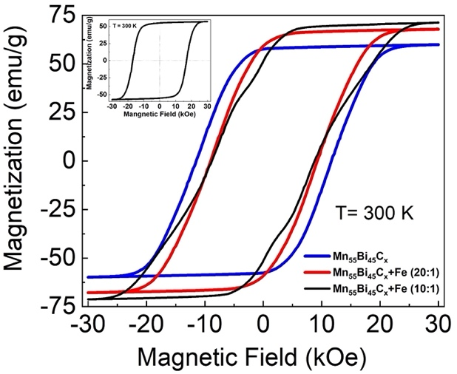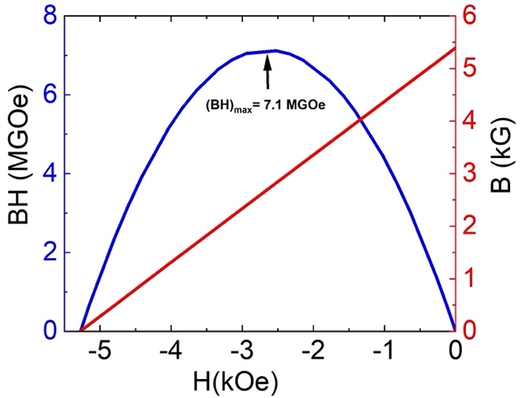
Figure 2: (a) Room temperature isothermal magnetization curves M(H) of vacuum annealed Mn₅₅Bi₄₅Cx, Mn₅₅Bi₄₅Cx+Fe (20:1), and Mn₅₅Bi₄₅Cx+Fe (10:1) samples. The Inset shows the M(H) curve of Mn₅₅Bi₄₅Cx annealed in low hydrogen environment. (b) The BH versus H curve of vacuum annealed Mn₅₅Bi₄₅Cx.

Figure 2(b) shows the BH(H) curve for vacuum annealed Mn₅₅Bi₄₅Cx. The energy product ${(BH)}_{max}$ determined from this curve is 7.1 MGOe. This value is smaller than that expected for a magnet showing an ideal square hysteresis loop (${J_{s}^{2}}/{4=---). }$Although the saturation magnetizations for composite magnets are significantly larger than that of Mn₅₅Bi₄₅Cx, their energy products ${(BH)}_{max}$ are small mainly due to small values of M_{r}/M_{3T} (see table 1). We note that ${(BH)}_{max}$ depends on coercivity, remanence and the squareness of the hysteresis loop.
Table 1:
Samples | M_{3T} (measured)  $±2$emu/g | M_{3T}(Expected)  $±2$emu/g | (BH)_{max}  MGOe | H_{c}  KOe | M_{r}/M_{3T}  (%)
Mn₅₅Bi₄₅C_{x} (original)  Mn₅₅Bi₄₅C_{x} (annealed in Hydrogen) | 60 | - | 7.1 | 12  17 | 97
Fe particles | 205 | - | - | - | -
C coated Fe particles | 135 | - | - | - | -
Mn₅₅Bi₄₅C_{x} +Fe (10:0.5) | 68 | 67 | 6.1 | 9 | 87
Mn₅₅Bi₄₅C_{x} +Fe (10:1) | 71 | 73 | 4.1 | 8.8 | 73
Mn₅₅Bi₄₅C_{x} +Fe (10:2) | 79 | 84 | - | - | -
Mn₅₅Bi₄₅C_{x} +C coated Fe (10:2) | 74 | 72 | - | - | -

- Conclusions
- Acknowledgments
This research is supported by South Dakota-NASA EPSCoR Research Initiation Grant no 80NSSC19M0063.

References
- F. Ronning and S. Bader S, Rare earth repalcement magnets J. Phys.:Condens. Matter, 26, (2014), 060301.
- D. Goll, R. Loeffler, J. Herbs, R. Karimi, and G. Schneider, High-throughput search for new permanent magnet materials J. Phys.:Condens. Matter, 26, ( 2014 ) 064208.
- R. Skomski, J. M. D. Coey, Permanent Magnetism, Institute of Physics, Bristol 1999.
- J. M. D. Coey, Permanent magnet applications, J. Magn. Magn. Mater, 248, (2002), 441.
- W. Zhang, X. Z. Li, S. Valloppilly, R. Skomski, J. E. Shield, D. J. Sellmyer, Magnetism of rapidly quenched rhombohedral Zr₂Co₁₁-based nanocomposites J. Phys. D: Appl. Phys. 46 (2013), 135004.
- W. Y. Zhang, P. Kharel, T. George, X. Z. Li, P. Mukherjee, S. Valloppilly, and D. J. Sellmyer Grain alignment due to magnetic-field annealing in MnBi:Bi nanocomposites, J. Phys. D: Appl. Phys. 49, (2016), 455002 .
- W. Zhang, B. Balasubramanian , P. Kharel, S. Valloppilly, X. Z Li, L. Yue, R. Skomski, R. Pahari, and D. J. Sellmyer, High energy product of MnBi by field annealing and Sn doping APL Mater. 7, (2019), 121111.
- B. Balasubramanian, B. Das, R. Skomski, W. Y. Zhang, and D. J. Sellmyer, Novel nanostructured rare-earth-free magnetic materials with high energy products, Adv. Mater. 25, (2013), 6090.
- Y. Huh, P. Kharel, V. R. Shah, E. Krrage, R. Skomski, J.E. shield, and D. J. Sellmyer,Magnetic and Strructural Properties of Rapidly Quenched Tetragonal Mn3-xGa Nanostructures, IE Trans. Magn. 49, (2013), 3277.
- S. Goto, H. Kura, E. Watanabe, Y. Hayashi, H. Yanagihara, Y. Shimada, M. Mizuguchi, K. Takanashi, and E. Kita, scientific reports , 7, 1(2017), 3216.
- B. Das , B. Balamurugan , Pankaj Kumar , R. Skomski , V. R. Shah , J. E. Shield , A. Kashyap , and D. J. Sellmyer, HfCo7-based rare-earth-free permanent magnet alloys, IEEE Trans. Magn. 49, (2013), 3330.
- N. Tang, Z. Chen, Y. Zhang , G. Hadjipanayis , F. Yang , Nanograined YCo₅-based powders with high coercivity, J. Magn. Magn. Mater 219, (2000), 173.
- J. B. Yang, Y. B. Yang, X. G. Chen, X. B. Ma, J. Z. Han, Y. C. Yang, S. Guo, A. R. Yan, Q. Z. Huang , M. M. Wu , D. F. Chen, Anisotropic nanocrystalline MnBi with high coercivity at high temperature Appl. Phys. Lett. 99, (2011), 082505
- P. Kharel , V. R. Shah , R. Skomski , J. E. Shield , and D. J. Sellmyer, Magnetism of MnBi-based nanomaterials, IEEE Trans. Magn. 49, (2013), 3318.
- T. R. Paudel, B. Lama, and P. Kharel, Ab initio study of alloying of MnBi to enhance the energy product RSC Adv. 11, (2021 ), 30955.
- R. Skomski and J.M.D. Coey, Giant energy product in nanostructured two-phase magnets, Phys. Rev. B 48, (1993), 15812.
- J. Park, Y-K. Hong, W. Lee, S-G. Kim, C. Rong, N. Poudel, J. P. Liu, C-J Choi, A Simple Analytical Model for Magnetization and Coercivity of Hard/Soft Nanocomposite Magnets, Scientific reports, 7, (2017), 4960.
- T. R. Gao, L. Fang, S. Fackler, S. Maruyama, X. H. Zhang, L. L. Wang, T. Rana, P. Manchanda, A. Kashyap, K. Janicka, A. L. Wysocki, A. T. N’Diaye, E. Arenholz, J. A. Borchers, B. J. Kirby, B. B. Maranville, K. W. Sun, M. J. Kramer, V. P. Antropov, D. D. Johnson, R. Skomski, J. Cui, and I. Takeuchi, Large energy product enhancement in perpendicularly coupled MnBi/CoFe magnetic bilayers, Phys. Rev. B 94, (2016), 060411(R).
- P. Kharel, B. Lama, M. Flesche, Z. Mehlberg, B. Lamsal, S. Valloppilly, Y. Zhou, D. J. Sellmyer and T R Paudel, Modifying magnetic properties of MnBi with carbon: an experimental and theoretical study, J. Phys. D: Appl. Phys. 55, (2022), 265003.

